Fabulous Fruits in your Neighbourhood
Challenge yourself to find all of these examples showcasing seed dispersal! Draw or photograph these and share them with @ubcphasoutreach and @beatymuseum! Check them off on this list once you’ve found them.
Remember to be mindful during your exploration, and return the seeds and fruits to where you found them once you’ve taken a photo or sketched your fruit! If you need more pictures to help you find the plants, you can always use the plants name to search for more online.
This worksheet should be used with reference to “Challenge No. 5: Build your own wind-dispersed seeds”, part of the “Physics & Astronomy at Home” series on the UBC Physics & Astronomy Outreach website at https://bit.ly/PHASWind.

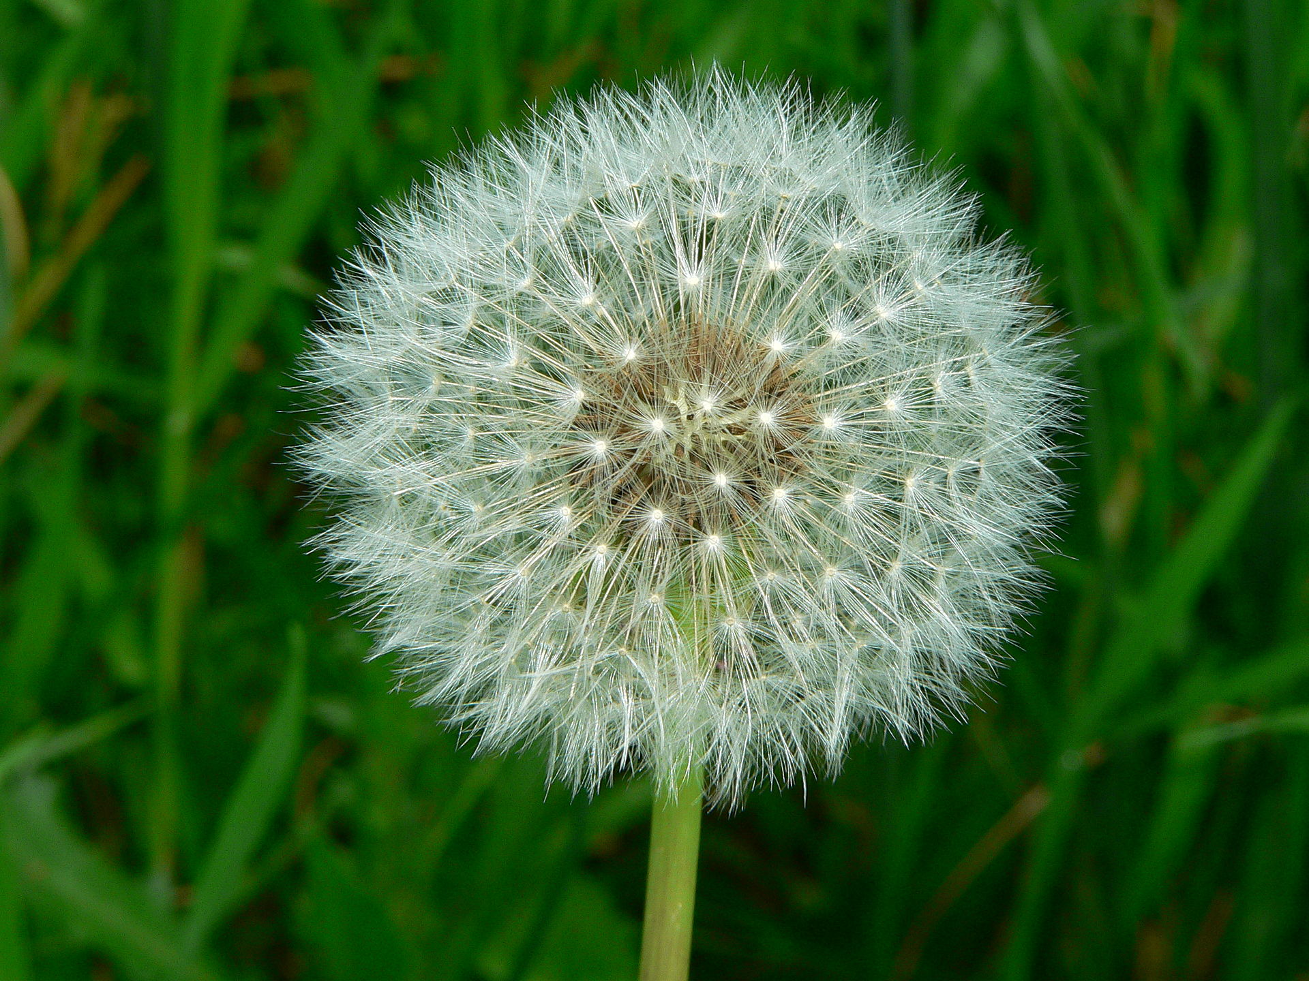
Fluffy seeds
One type of wind-dispersed seed you’ve probably seen before is a dandelion. There are lots of other wind-dispersed seeds that are fluffy though, like cottonwood seeds. In the spring, there can be so many cottonwood seeds it’s like a snowstorm!

Where I found a fluffy seed:

Photo by Greg Hume
Other observations:

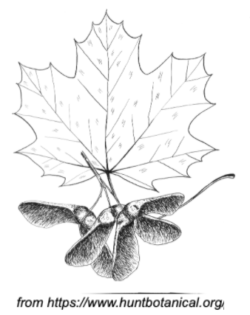
Helicopter seeds
Maple seeds are a very fun example of wind-dispersed seeds. Look for the distinctive Maple leaf shape, and for two of the seeds attached together, sometimes coming in bunches.

Hold just one seed and throw it into the air to watch it helicopter down! (Be careful of seeds that look fuzzy - those one can make you itchy)

Where I found a helicopter seed:

Other observations:

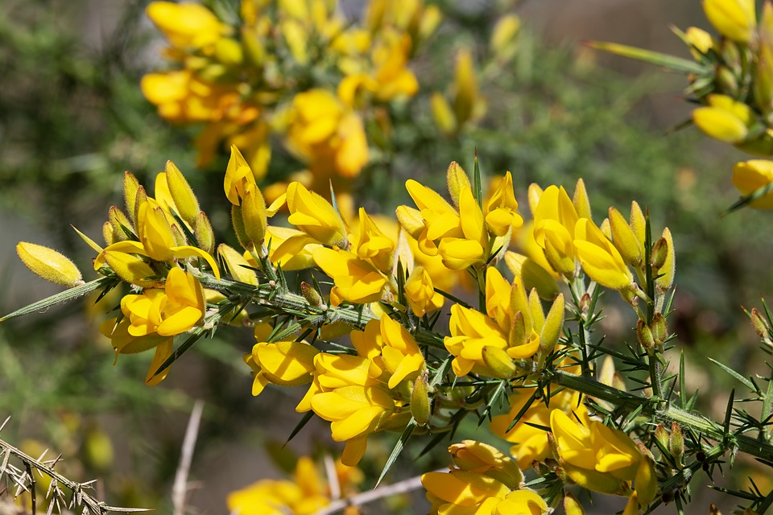
Explosive pods
Gorse is a shrub that often grows in ditches or in meadows. It has bright yellow flowers that smell like peas, and it grows purple seed pods. On hot days at the end of the summer the pods can burst, shooting seeds out. If you find a purple seed pod you can try poking it - it might explode!

Himalayan Balsam is another plant that uses explosive seed dispersal - check the next section for more.

Where I found an exploding seed pod:

Other observations:

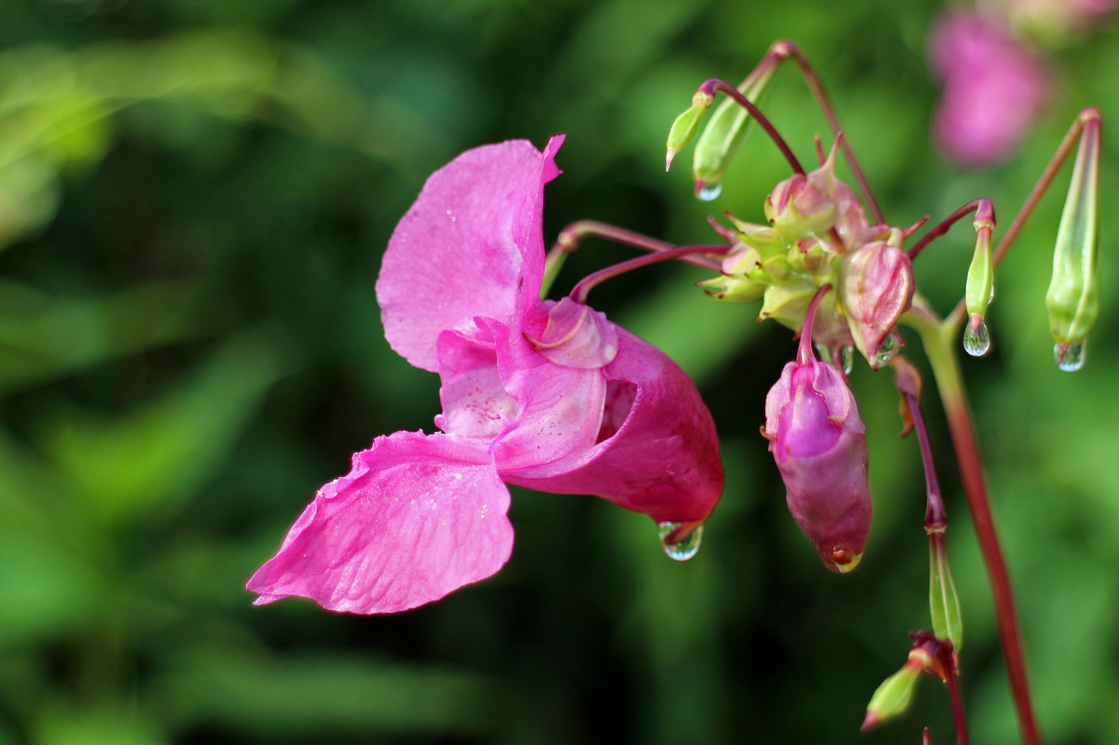
Water travelling seeds
Himalayan Balsam is a plant that has exploding seed pods, similar to gorse, but also has another trick up its sleeve. Himalayan Balsam likes to grow next to water, and its seeds float. This lets the seeds travel long distances along creeks and rivers, spreading the plant.

Several other species also use the water to disperse their seeds. Can you find any plants near water that seem like they might be doing this?

Where I found a water-dispersed seed

Other observations:

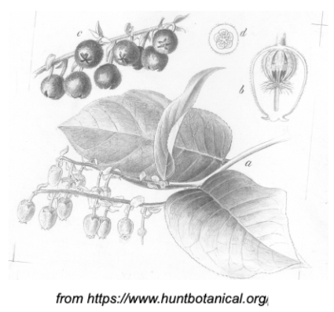

Gut travelling seeds
Some seeds travel by being eaten (on purpose!). One example of this is Salal, which has waxy green leaves, white flowers, and red berries. The berries contain seeds, and when animals eat the seeds they carry them far away.
Other examples of gut-travelling seeds you might find in your neighbourhood are oregon grape, Himalayan or trailing blackberries, and thimbleberries.

Where I found a gut travelling seed:

Other observations:

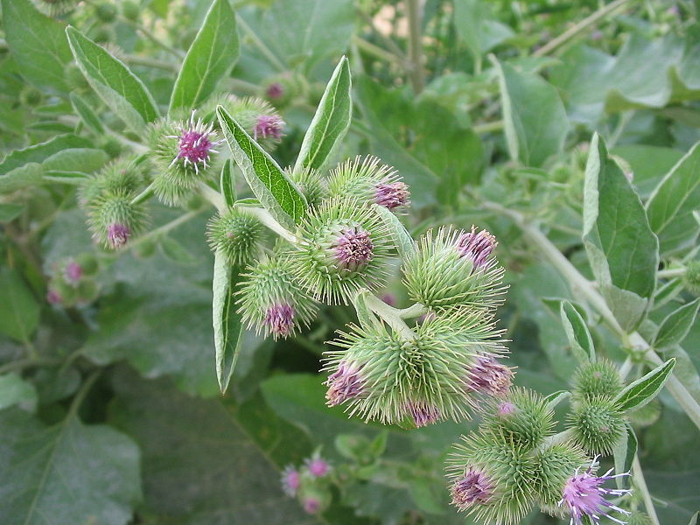
Fur travelling seeds
Some seeds like to hitch a ride on an animal's fur. To do this, they use burrs. These are small flexible hooks that grab onto fur or clothing. One example of a plant in B.C. that does this is Burdock.
There are lots of other kinds of plants with burrs. In fact, if you’ve already been outside looking for some of the plants above, you might already have a burr stuck to you!

Where I found a fur travelling seed:

Other observations:

