The Quantum Circuit Challenge (solutions):
Note: In many cases several different solutions are possible. We’ve provided one.

Challenge 1 - Up, down, left, right: Create a quantum circuit that puts the qubit into each of the 4 states up, left, down, right (in any order, look at the picture on the top left to see what state you are in)

Solution:

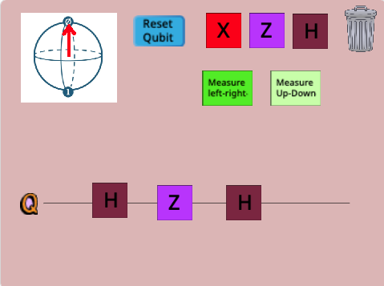

Challenge 2 - Making randomness: Build a circuit and choose a measurement at the end so that the result of the measurement is random.
This means that when you run the same circuit a few times the measurement at the end will sometimes say "up" and sometimes say "down" OR, sometimes it will say "left" and sometimes say "right".
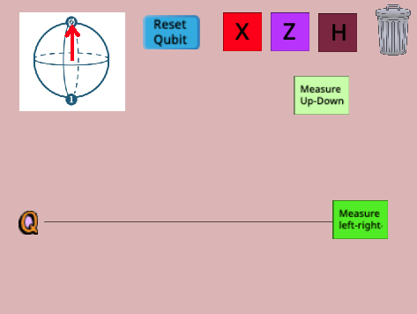
Challenge 3 - Doing and undoing: Start your circuit with an X gate. Then, add gates so that the effect of your circuit is to do nothing at all.
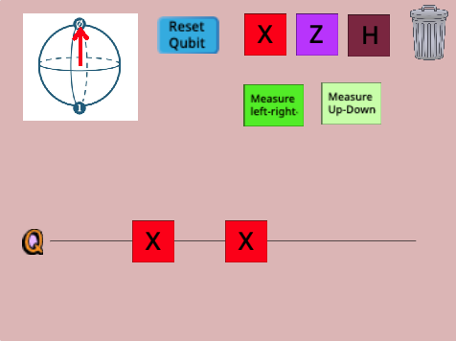
Challenge 4 - Doing and undoing: Start your circuit with a Z gate and then an H gate. Then, add gates so that the effect of your circuit is to do nothing at all.
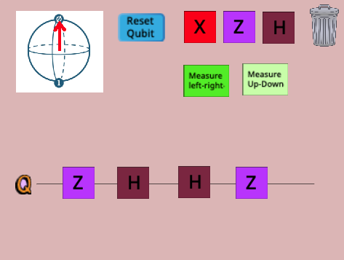
Challenge 5 - Flipping without X gates: Create a circuit that takes in an "up" state and sends out a "down" state, but, create this circuit without ever using an X gate!

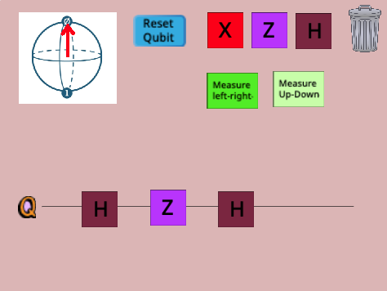

Challenge 6 - Useless gates: Create a circuit where the X gate doesn't do anything. you'll need at least one gate before the X gate so that the qubit going into the X gate isn't in the "up" state!

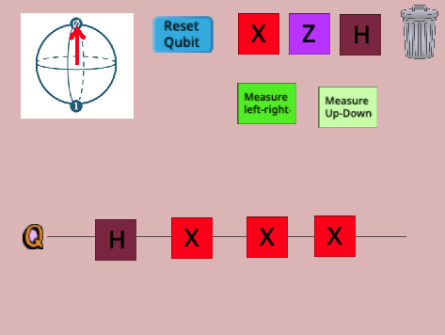

Challenge 7 - XH vs HX: Find two gates which create different circuits when put in a different order.
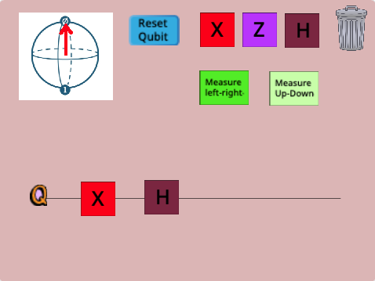
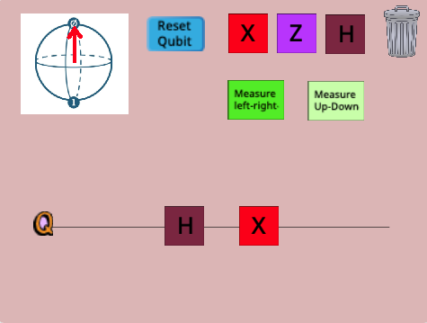
Challenge 8 - XH vs HX: Find two gates which create the same circuit when put in a different order.
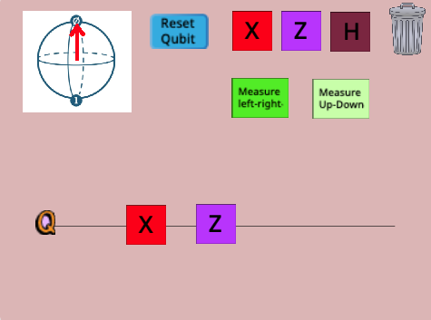
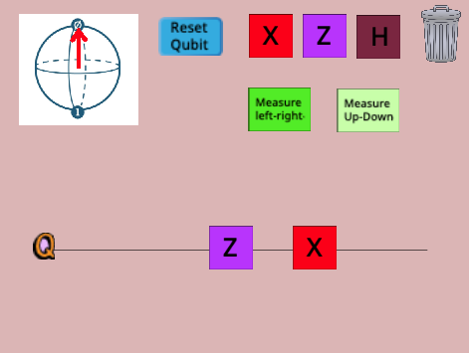
Challenge 9 and 10: These are open ended challenges so we can’t really provide a “solution”. Please contact us though if you have questions!

