The Quantum Circuit Challenge
Want to master quantum gates and circuits? Take our quantum circuit challenge! You’ll learn more about quantum states, and how we can use quantum gates to change them. At the end, you’ll have a chance to create and share your own quantum gate, and to check out other people’s projects.

This worksheet should be used with reference to “Challenge No. 7: Repair a quantum teleporter”, part of the “Physics & Astronomy at Home” series on the UBC Physics & Astronomy Outreach website https://bit.ly/PHASQuantumTeleporter.

This challenge uses the “One Qubit Circuit (UBC)” Scratch project: https://scratch.mit.edu/projects/416306608/.

Challenge 1 - Up, down, left, right: Create a quantum circuit that puts the qubit into each of the 4 states up, left, down, right (in any order, look at the picture on the top left to see what state you are in)

Challenge 2 - Making randomness: Build a circuit and choose a measurement at the end so that the result of the measurement is random.
This means that when you run the same circuit a few times the measurement at the end will sometimes say "up" and sometimes say "down" OR, sometimes it will say "left" and sometimes say "right".
Challenge 3 - Doing and undoing: Start your circuit with an X gate. Then, find a second gate which “undoes” the effect of the X Gate.
Challenge 4 - Doing and undoing: Start your circuit with a Z gate and then an H gate. Then, add gates so that the effect of your circuit is to do nothing at all.
Challenge 5 - Flipping without X gates: Create a circuit that takes in an "up" state and sends out a "down" state, but, create this circuit without ever using an X gate!

Challenge 6 - Useless gates: Some states are unaffected by particular gates. For example, if you have an up state and then do a Z gate, you’ll still have an up state.

Using your circuit simulator, figure out which state is unaffected by an X Gate.

Challenge 7 - XH vs HX: Find two gates which create different circuits when put in a different order.
Challenge 8 - XH vs HX: Find two gates which create the same circuit when put in a different order.
Hint - try a circuit with an X gate then an H gate, and compare this to an H gate and then an X gate. Try this again with X and Z.
The final two challenges require you to have a Scratch account, which you can sign up for here: https://scratch.mit.edu/join. You can also check out the “Build your own solar system” page https://bit.ly/3dfPVte for more tips on getting started with Scratch.
Challenge 9 - Create your own gate: In this challenge you’ll edit the Scratch project to create your own gate. To edit the project, click on “See inside”,

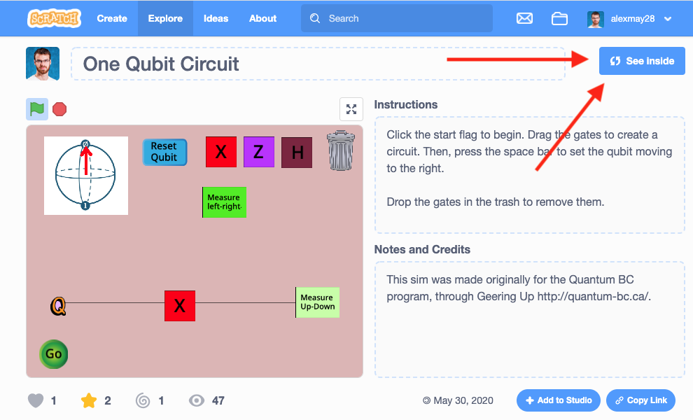
To get started, look for the "my gate" sprite. In the code you'll notice a "show" block and a "hide" block. Click the "show" block.
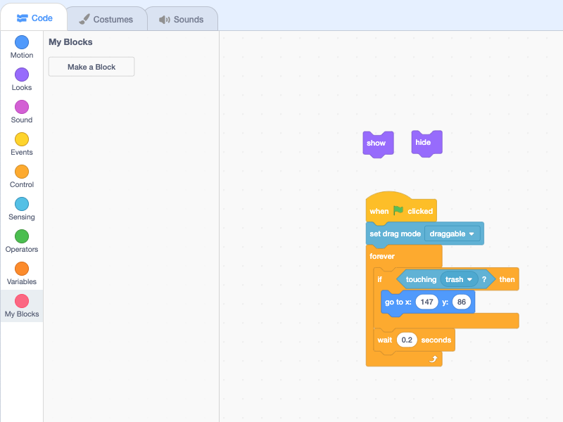
A new sprite will appear in the circuit editor. You can go to the "costumes" tab to change the appearance of your gate (Make sure to keep your gate as a square and don't change the size, or the circuit won't work properly!)
Next go to the Q sprite. You'll need to use an "if" statement so the qubit checks if it is touching the new gate sprite. Then inside the if statement build your quantum gate! You can create a new gate by putting together a few of the existing gates.

Here's an example:
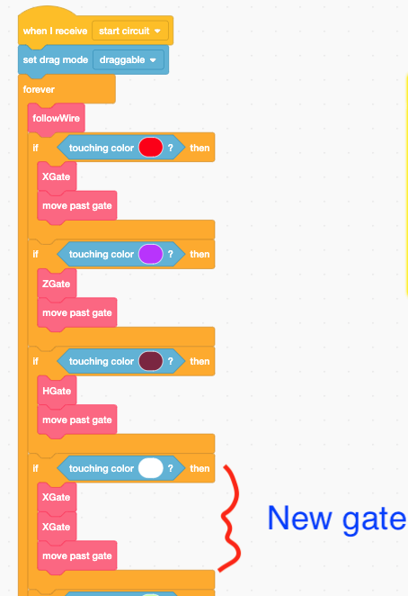
Remember that you can always restart by creating a new remix of the original project: https://scratch.mit.edu/projects/400546699/

Challenge 10: Once you've created your own quantum gate, you're ready to share your Scratch project!

Add your project to the "One Qubit Circuit" Scratch studio: https://scratch.mit.edu/studios/27292000/

Next, check out 2-3 other projects in the Scratch studio. Without looking inside their code, can you figure out what their mystery gate is? How is it built out of the X,H, and Z gates? Post your guess in the comments on their Scratch project page.

