Worksheet No.6 – Rockets
Unlike a boat, rockets don’t need water to float on, and unlike planes, they don’t need air to pass under their wings. In fact, rockets can push themselves forwards even in the emptiness of space, by throwing their exhaust backwards. That’s why rockets are humans’ ride into outer space.

This worksheet should be used with reference to “Challenge No. 6: Build your own rocket!”, part of the “Physics & Astronomy at Home” series on the UBC Physics & Astronomy Outreach website https://bit.ly/PHASRocket.

Action and reaction
In the video with the astronauts, when the astronaut throws a basketball he doesn’t move very much. But, when he pushes his friend he moves a lot. Why is that?

The Saturn V rocket (used to take humans to the moon) used 18,000 kg of fuel every second. Why do you think the Saturn V had to use so much fuel?

Pressure and air resistance

What is pressure? Give an example where you can feel the pressure of air on your body.

If you drop a feather and a bowling ball at the same time on the moon, where there is no air, they hit the ground at the same time. If you do this on Earth the feather falls much more slowly than the bowling ball. Why is this?

(Hint: you can learn more about pressure and air resistance by checking out challenge No. 5 - https://bit.ly/PHASWind )

Mass changes
Remember from the webpage that

Acceleration = Force / Mass

The force for a rocket is provided by the rocket engine - a strong engine will give a larger force, and so a larger acceleration. Rocket engineers also try to make their rockets as light as possible. Why do they do this?

Many rockets use something called stages:

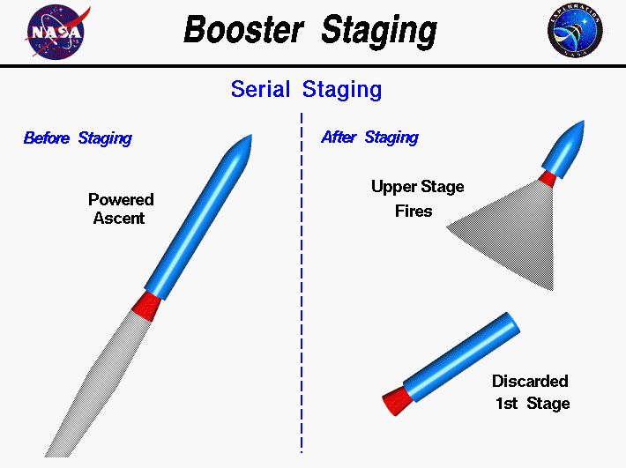

The rocket has two sections, and each has a tank of fuel inside. Once the first fuel tank is empty, the rocket drops that section and starts using the fuel from the second section.
Why do you think that rockets uses stages?

(Hint: the fuel tank is pretty big and heavy…)

Bonus challenge
Check out the rocket simulator here: https://scratch.mit.edu/projects/416308884/ The simulator uses real physics to determine how the rocket should move.

Your challenge is to make the rocket reach 10,000 m. Use what you’ve learned about rocket physics to complete your challenge! If you reach 10,000 m you’ll see a little character floating in the sky. Draw that character here to prove you really got there!

Hint: Click the “Change Rocket” button to adjust your rocket.

